Quality Assurance Document for PIM GUI

Contents

Role Designation 2

Database 3

Application Design and Installation 3

# 

# Role Designation

This is the quality assurance documentation for the creation of the Graphical User Interface for the Personal Information Management section of the project.

The members of the PIM group include:

* Nisa Shahril
* Jacob Beynon
* Lewis Impey
* Ryan Murunga

After a team meeting, the roles of each member have been decided based upon the skills that they have and what they would feel the most comfortable doing:

Jacob Beynon – Jacob will be in charge of the actual creation of the GUI for the group. Since Jacob is already experienced in using python and enjoys coding, we collectively decided that he would be the best for that role. We decided to use PyCharm and TKINTER for the creation of the GUI as we already need to learn python as a part of this module so it would make the most sense to use the same language that we are learning.

Lewis Impey – Lewis will take the role of creating the quality assurance documentation for the team and the creation of the design for the GUI. Lewis was chosen to do the quality assurance documentation and the design as both of these go hand in hand as the quality assurance documentation states what the GUI should have and the design is just a visual representation of that.

Nisa Shahril – Nisa will take on the role of organizing the team’s collaboration tools such as the Trello board and creating the PowerPoint for the group seminar. We decided upon this as a group because we believe that Nisa is the best at organization within the group and would be the best at keeping the team on track and reminding everyone as to what they should be doing at any given time.

Ryan Murunga – Ryan will be taken the responsibility of writing the terms and conditions (LSEPI) documentation for the GUI as we believe that he would be the best fit for writing documentation such as this.

# Database

The database that we will be using for the GUI will be SQLite as SQLite was provided to use with a demonstration as to how it works and is the most appropriate for the GUI that we will be building – **ADD TO THIS LATER**

# Application Design and Installation

When creating the simple login system, the GUI should be big enough for any person to read, and big enough to accommodate all of the needed buttons, labels, and textboxes. These should be big enough for any person to easily identify, including a person that may have a disability that may hinder their ability to perceive the screen. The text contained within the GUI should also be big enough for anyone to read, including someone that may have difficulty reading. The text on the GUI should use fonts that are simple and not too invasive of the reader when they are navigating through the system. As for the colours that the GUI will use, we will make sure that the GUI is suitable to colour-blind people, so the colours that will be used should be suitable for non-colour-blind users whilst also accommodating a colour-blind user’s viewing experience.

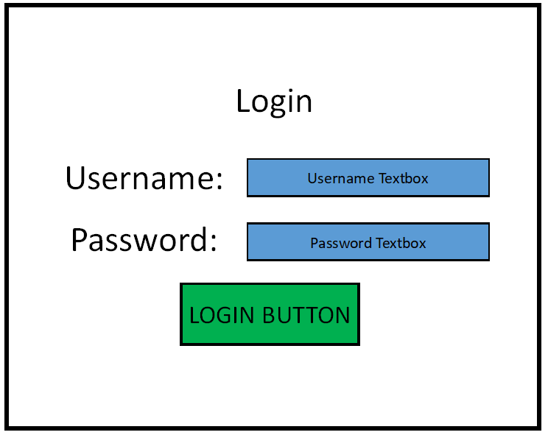When the program is loaded up, the user should be greeting with a form that contains a title and the logo of the company. The user should be able to click a drop-down box in the top left to allow them to open up the login form that will contain username and password labels, along with textboxes for each of these where the user would enter the relevant information. There should also be a login button which when pressed should scan the database and check to see if the username and password are correct and should then log the user in. If the entered information is incorrect, a message box should appear making the user aware that their information was incorrect. If the user is logged in as a normal user, then the user should have another form available to them which should allow them to view the records on the database and search for specific records. If the user is logged in as an admin, the user should have the same form available to view records as a normal user, however the admin should also have additional buttons and options allowing them to add, modify, or delete a record.

To make sure that logging into the system is secure, when a user types in their password, instead on displaying what there are typing in to the textbox, it will instead show “*” characters as to prevent anyone from seeing what their password is.

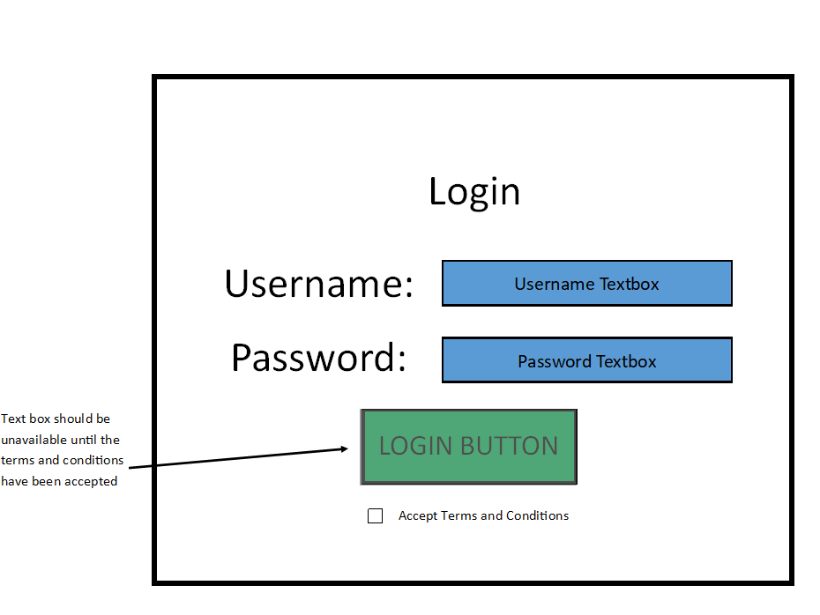

To make sure that security is kept, the login button should be unavailable to click if the user has not read the terms and conditions and accepted them below the login button. Upon accepting the terms and conditions, the login button should become enabled. This is in place to make sure that every user that logs into the system accepts the terms of using the system and are aware of what rules they must follow.